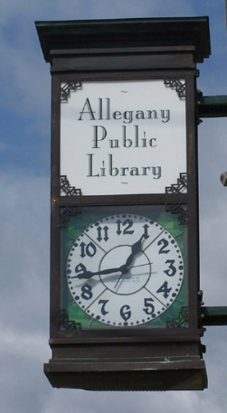
1,175 Registered Users
474 Village Users
720 Town Users
6,120 Total Library Visits
1,560 Computer Sessions
962 WiFi Sessions
1,131 Reference Q&As

Join us Summer 2025 for
Our Reading Program!
Activities and Prizes!
Library Services:
Public computers
Fax/Printing Access
Children’s Programs
Interlibrary Loans
Free WiFi
Magazines, Local Newspapers
Med Station
VHS Converter
2,321 Adult books borrowed
1,606 Children’s books borrowed
1,135 Other Items Borrowed
2,060 Electronic Materials borrowed
35,320 Printed Books
3,624 Movies on BluRay and DVD
Ebooks and Audio available via Libby
Downloadable Movies
Audio Books on CD

Allegany Public Library
90 West Main St.
Allegany, NY 14706
716-373-1056
Monday-Friday: 10-6pm
www.alleganylibrary.org

2024 Annual Report for the Community

